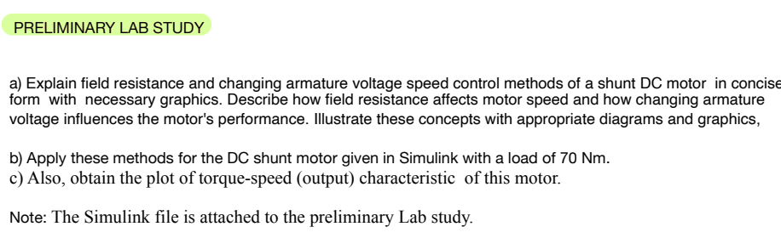

All the measurements and comments made according to 70 Nm Torque. Because the previous torque value is unknown in the given Simulink file.
Obtained Graphs
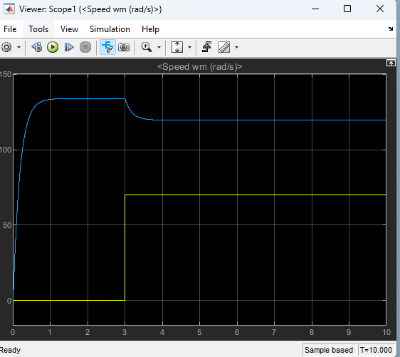
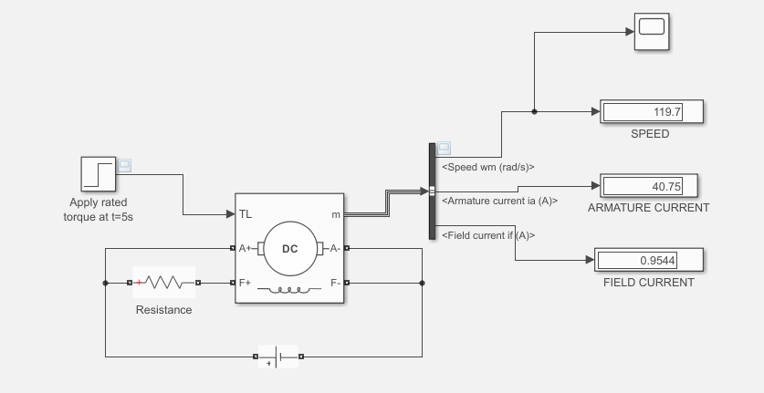
1 OHM - 70nm - 230V

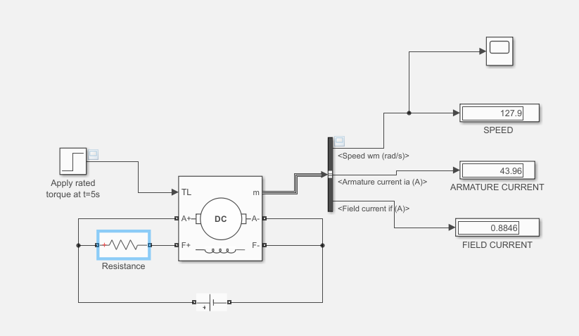
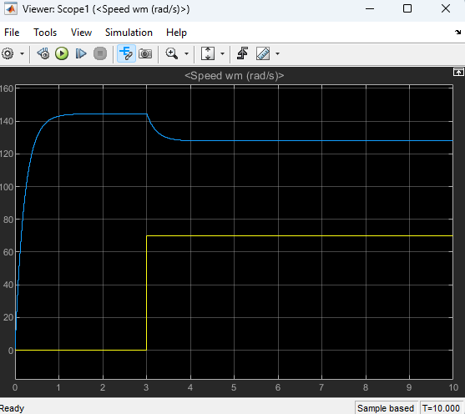
20 OHM - 70nm - 230V

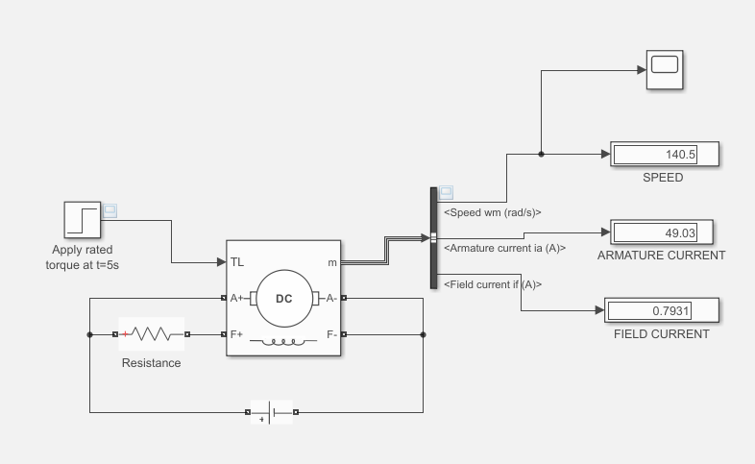
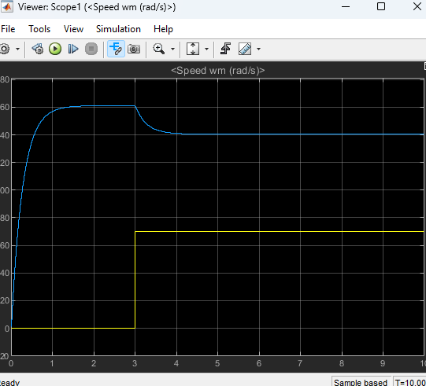
50 OHM - 70nm - 230V

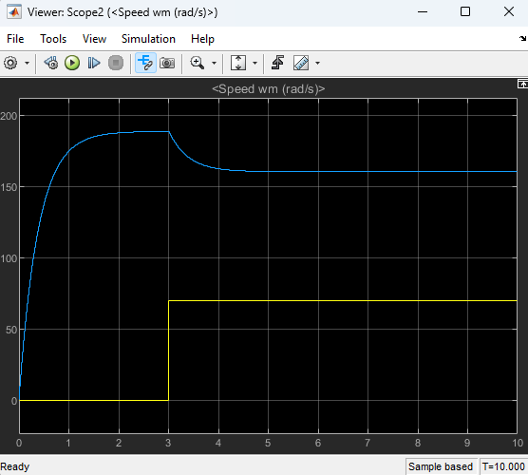
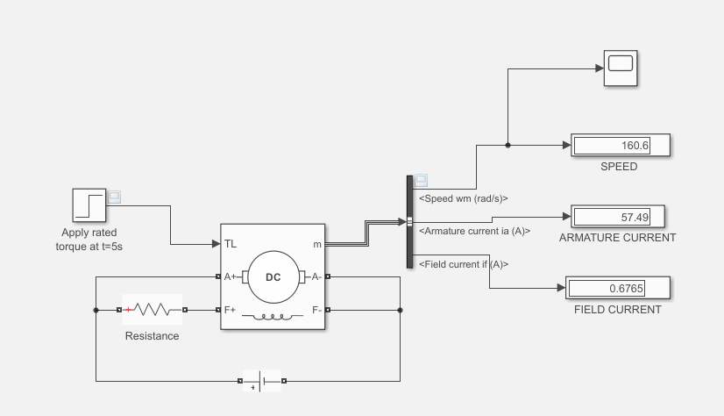
100 OHM - 70nm – 230V

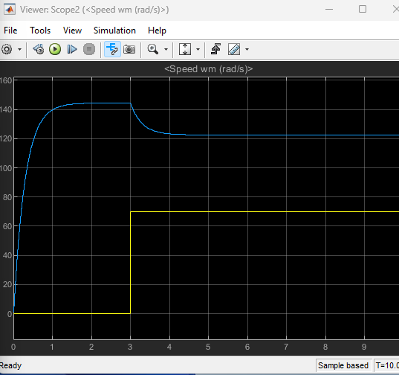
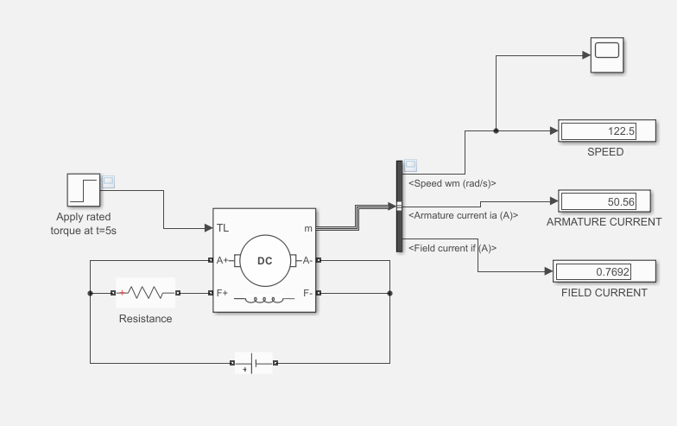
20 OHM - 70nm – 200V

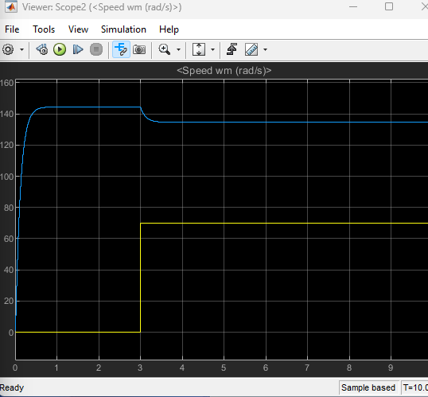
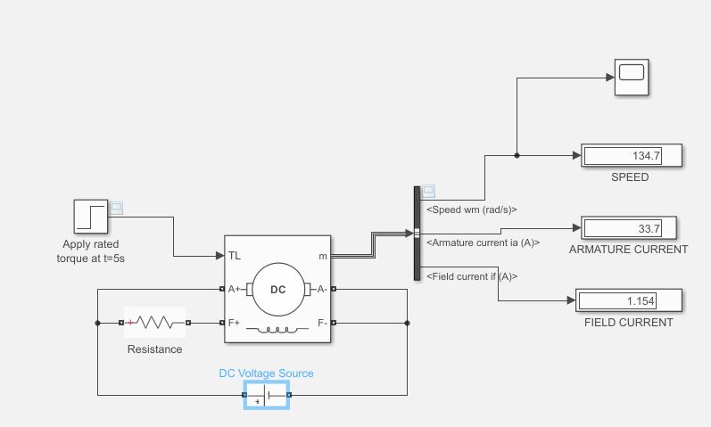
20 OHM - 70nm – 300V

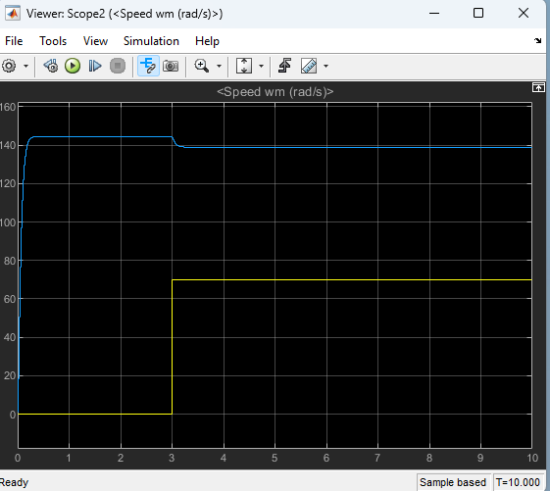
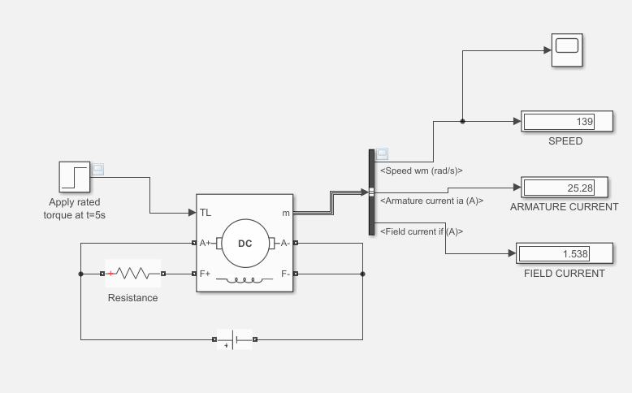
20 OHM - 70nm – 400V

Conclusion
By changing the field resistance, we can control the strength of the magnetic field produced by the field winding. This, in turn, affects the motor's speed.
When field resistance is increased, the field current decreases, weakening the magnetic field. As a result, the motor's speed increases.
When field resistance is decreased, the field current increases, strengthening the magnetic field. This causes the motor's speed to decrease.
As you can see in the graphs above when the field resistance increased, the motor's speed will increase. When the field resistance is decreased, the motor's speed will decrease.
As you can see in the graphs above, when the armature voltage increased, the motor's speed will increase. When the armature voltage is decreased, the motor's speed will decrease.

